1. What to do if you cannot access the DSC-ID password change screen

Launch "Internet Explorer".

Double-click the following icon to open it.



1. Open the following URL.

<https://dscpwch.dir.globaldenso.com/chngpwd-en.htm>

Copy the URL, right click on the address bar of "Internet Explorer" and press paste.

Then press the Enter key to access.

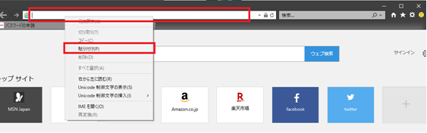

1. If the following screen opens, you can access normally.

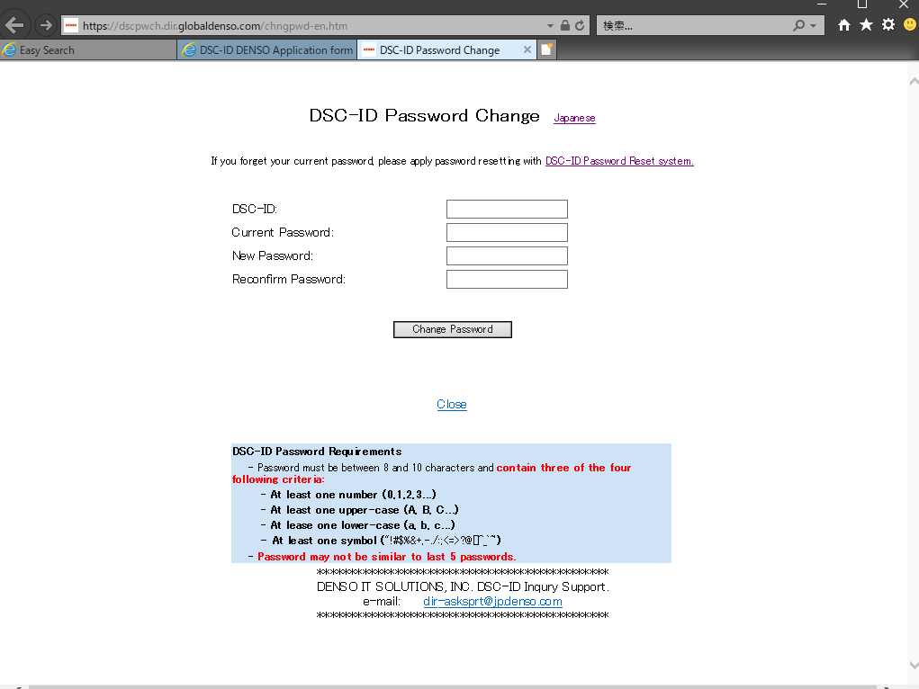

# What to do if "This page can't be displayed" is displayed

In this case, you can access by setting as follows.

1. Press the gear icon of "Internet Explorer" and select "Internet Options".

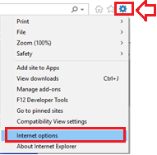

1. Open "Advanced" tab and enable the "Use TLS 1.0" checkbox, then click "Apply".

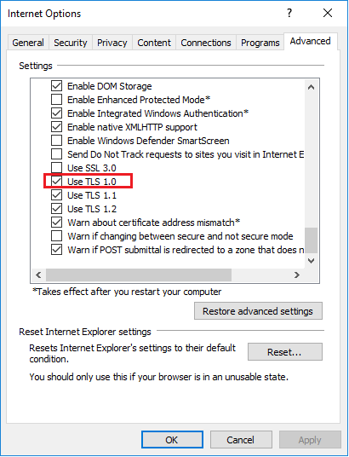

1. Press "OK" button and close "Internet Explorer".
2. Launch "Internet Explorer" again and access the "DSC-ID password change page".